

Version Number: 1.1

Version Date: 2019-05-07



Revision Log

|  |  |  |  |
| --- | --- | --- | --- |
| Version | Date | Author | Change Description |
| 1.0 | 2019-05-03 | Luke Thompson | Initial creation |
| 1.1 | 2019-05-07 | Luke Thompson | Completion of sections, reordering |
|  |  |  |  |
|  |  |  |  |

Contents

1. Overview 3

2. SLAs 3

2.1. Logic Overview 3

2.2. SLA – TELSU PSI Return Date 4

3. Business Processes 5

3.1. Incident 5

3.2. Service Request 6

4. Automation 7

4.1. Service Price 7

4.2. Create PSI Email 7

4.3. Automatic Generation of Order 7

5. Case Business Process Flow 8

# Overview

The purpose of the Case component in NGN’s Dynamics 365 instance is to help process Incidents and Service requests.

A Case will be created either by import from the Fujitsu Heat Helpdesk, or by an NGN User. It will be in response to a request or issue by a School District contact.

The Case is split between multiple **case types** and **case** **categories** which are filtered to help report and guide the users between different types of Case. It also alows users to track activities like emails and tasks against it via the timeline

# SLAs

## Logic Overview

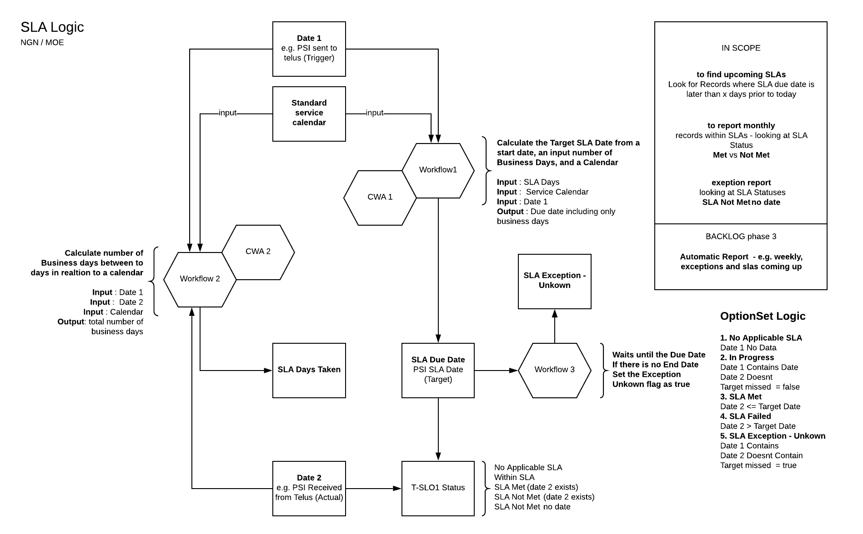There is one SLAs on the Case which this section will describe. It follows the following logic

## SLA – TELSU PSI Return Date

This Tracks the SLA Days and status between the **PSI Sent to TELUS** and the **PSI Returned** **Date**.

Multiple workflows are used to calculate this.

Note: All day and date calculations are made with respect to the NGN business calendar.

1. On **PSI Sent to TELUS** being set will fire a workflow to calculate and set the **Target Date**
2. On **Target Date** is set, a workflow runs and waits until that **Target Date**.
3. On **Target Date** is reached, if the **PSI Returned** **Date** is not set, the exception flag (hidden field) is set, as we do not know if the SLA has passed or failed.
4. On **PSI Returned** **Date** is set, a workflow calculates the SLA business days between the **PSI Sent to TELUS** and **PSI Returned** **Date**

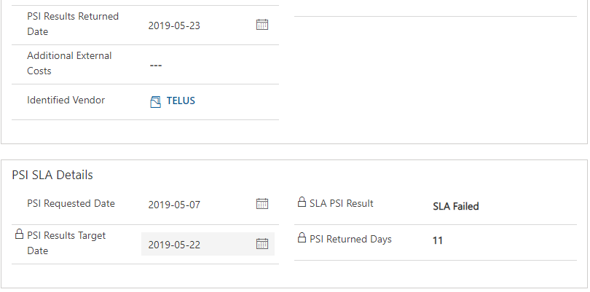

# Business Processes

The Case Entity is the main source of actions within NGN. They are given a type, category and subcategory.

The three types of cases are: Incident, service Request, Fujitsu Ticket.

## Incident

This includes both Internally raised Incidents and Imported Fujitsu Tickets.

It tracks the category and subcategory of the incident, along with notes and resolutions found.

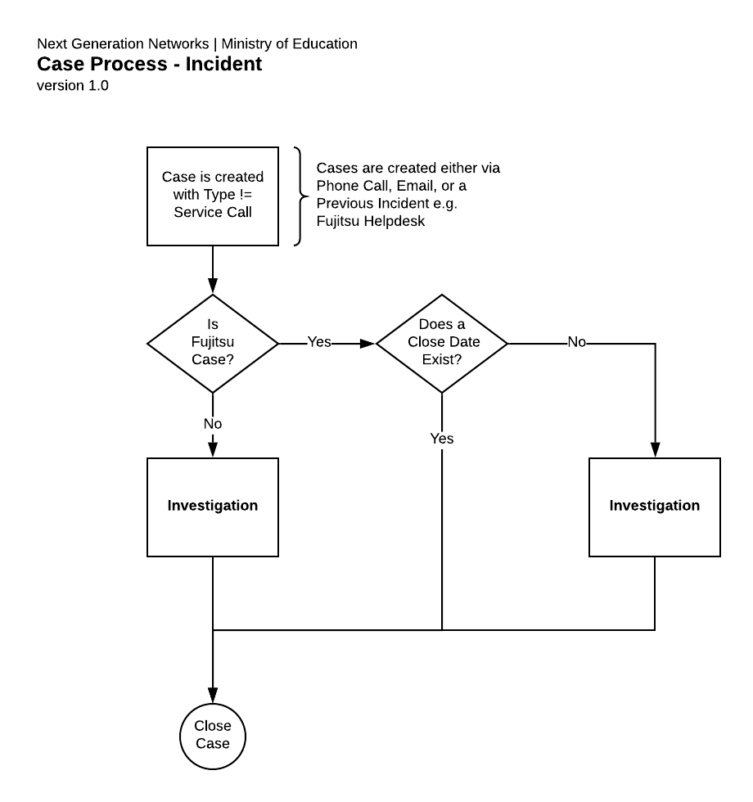

## Service Request

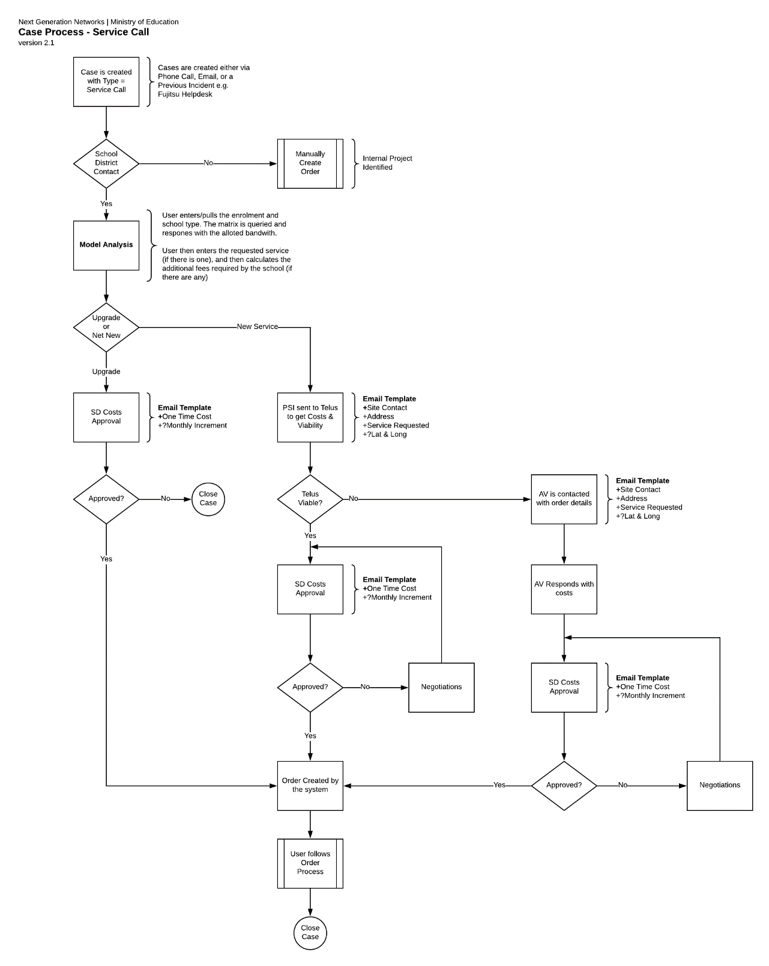A service request tracks the originator of the request, the request details - Request Type, the service requested, the price of that request, School District approval, and SLA dates and numbers.

# Automation

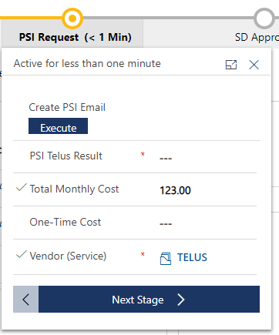

## Service Price

The Service Price is automatically pulled in from the Service record when it is set. This it to add effeciceny to the user journey, and reduce the number of clicks/page transitions needed.

## Create PSI Email

This allows users to automatically create an email to TELUS to request the costs and vaiablity of a service request. It is included in the PSI Request Stage of the Busines Process Flow.

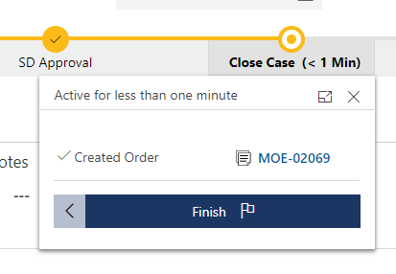

## Automatic Generation of Order

If the School District has approved the Costs in the Approval stage, then progress the business process flow will automatically create the order.

This will map the School District contact, prices, dates, and requested service from the Case to the newly created Order.

# Case Business Process Flow

Dynamics uses a Business Process Flow to manage the stages of a case.

The image below shows the stages (in blue) of the Case Flow with Logical decisions highlighted in purple.

